Assignment -1
Flask Assignment

Assignment Date
Student Name
Student Roll Number
Maximum Marks | 2 Marks

- Create registration page in html with username, email and phone number and by using POST method display it in next html page.

register.html
<html>
<head>
<title>Registration Page </title>
</head>
<body>
<form action="http://127.0.0.1:5000//register" method="POST">
<h1> Registration Form </h1>
<p> Enter your name : <input type="text" name="name"/></p>
<p> Enter your mail id: <input type="email" name="mail"/></p>
<p> Enter your phone number:<input type="number" name="phone"/></p>
<p> <input type="submit" value="submit"></p>
</form>
</body>
</html>

app.py
from flask import Flask,redirect,url_for,request
app=Flask(__name__)
@app.route('/success/<string:name>/<string:mail>/<string:phone>')
def success(name,mail,phone):
return "Name: " + name +" <br> Mail ID: "+mail+" <br> Phone number: "+phone

@app.route('/register',methods=['POST'])
def register():
if request.method=='POST':
user=request.form['name']
mailid=request.form['mail']
phonum=request.form['phone']
return redirect(url_for('success',name=user,mail=mailid,phone=phonum))

if __name__=='__main__':
app.run(debug=True)

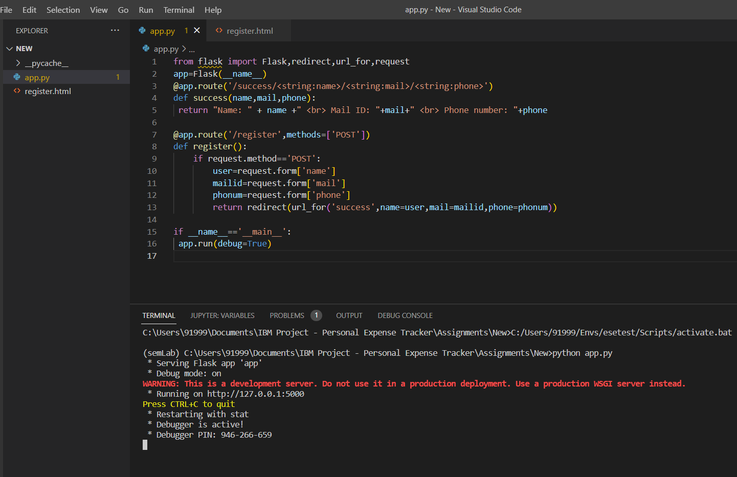

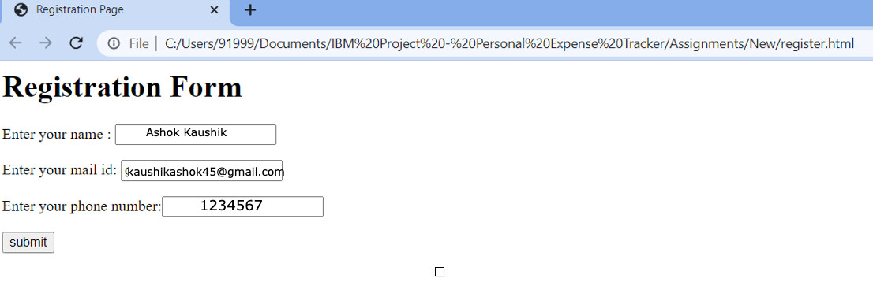

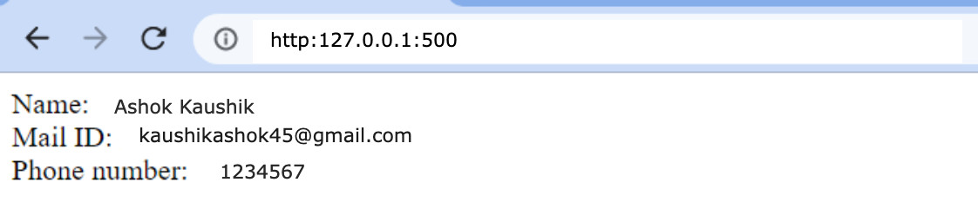
Caption
- Develop a flask program which should contain at least 5 packages used from pypi.org.

from flask import Flask, request, json
app = Flask(__name__)
student_marks = {"Gokul": 94, "Raam": 95, "Ashok": 95, "Serjeel": 99}

@app.route("/mark/<id>", methods=['PUT'])
def Op_update(id):
mark = request.form['student']
student_marks[str(id)] = mark
return 'Mark is Updated'

@app.route("/mark/<id>", methods=["DELETE"])
def Op_delete(id):
student_marks.pop(str(id))
return 'Record Deleted'

@app.route('/mark', methods=['GET', 'POST'])
def api():
if request.method == 'GET':
return student_marks
if request.method == 'POST':
mark = request.json
student_marks.update(mark)
return ' Student Record Inserted'

if __name__ == '__main__':
app.run(debug=True)

